
Cloud Computing Lab

Submitted to:
Engr. Muhammad Shoaib

Submitted by:
Hania Akbar

Reg no:
2023-BSE-026

Section:
A

Lab 9 – Codespaces + AWS: GH CLI (Codespaces), AWS CLI, EC2, IAM, Security Groups, Filters & Queries

Task 1 — GitHub CLI, Codespace setup and authentication
(Local desktop) Install GitHub CLI (Windows example via winget):
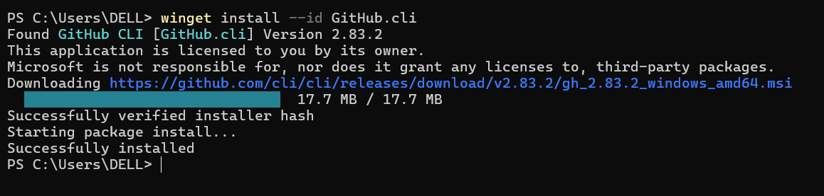

(Local) Authenticate GH CLI for Codespaces:
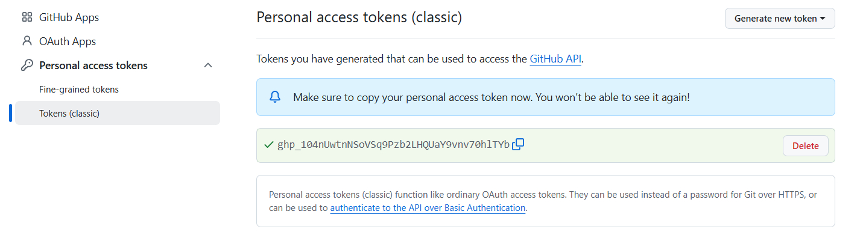
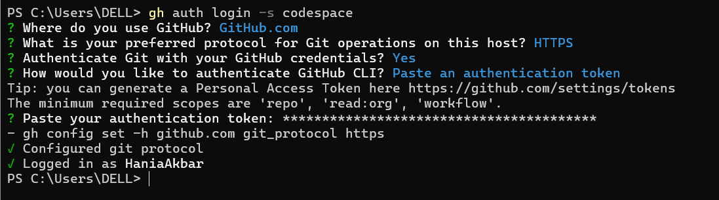

(Local) List available Codespaces (optional verification):
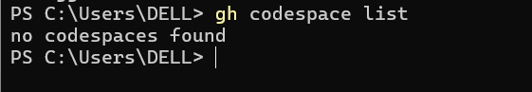

(Local) Create or connect to a Codespace. To create a new codespace from the current repo:

Task 2 — Install AWS CLI inside the Codespace and configure it
Goal: Install the AWS CLI in the Codespace and configure it to interact with your AWS account.
Inside the Codespace shell run:
- Download and install AWS CLI:
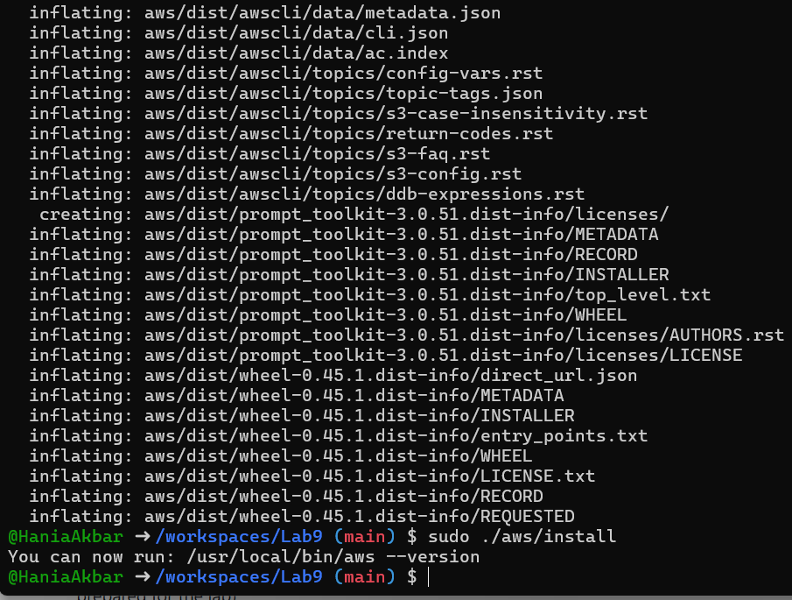

Verify installation:
Configure the AWS CLI (you will provide Access Key ID and Secret Access Key for a user with permissions, or use root/IAM user you prepared for the lab):

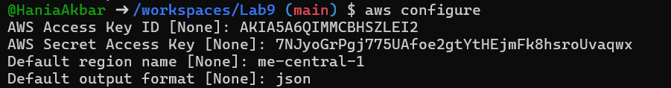

Verify credentials/config files:

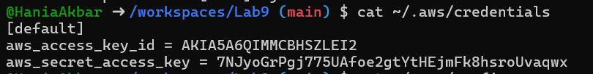
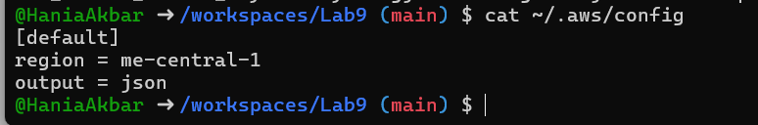

Verify connectivity (you should see a JSON result showing your caller identity):
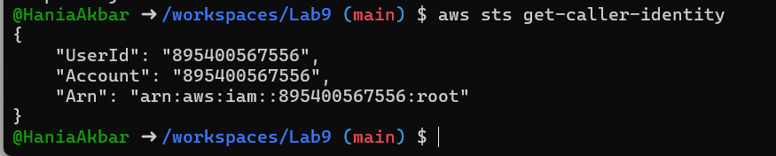

Task 3 — Create security group and add ingress rules using Codespace IP
Goal: Create an EC2 security group, inspect it, add an SSH rule for your Codespace public IP, and verify.
Steps (run in the Codespace shell):
- Create a security group (substitute your VPC id):

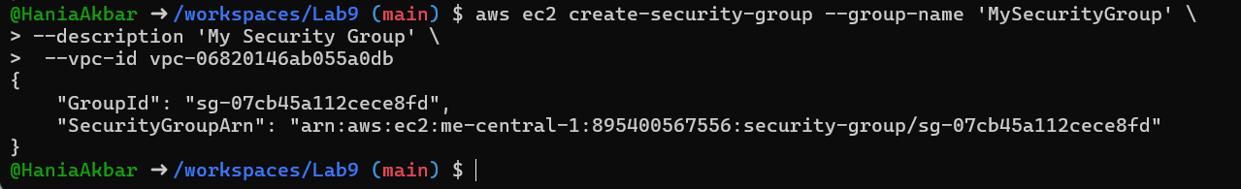

Inspect the security group (initially ingress will be empty or default):
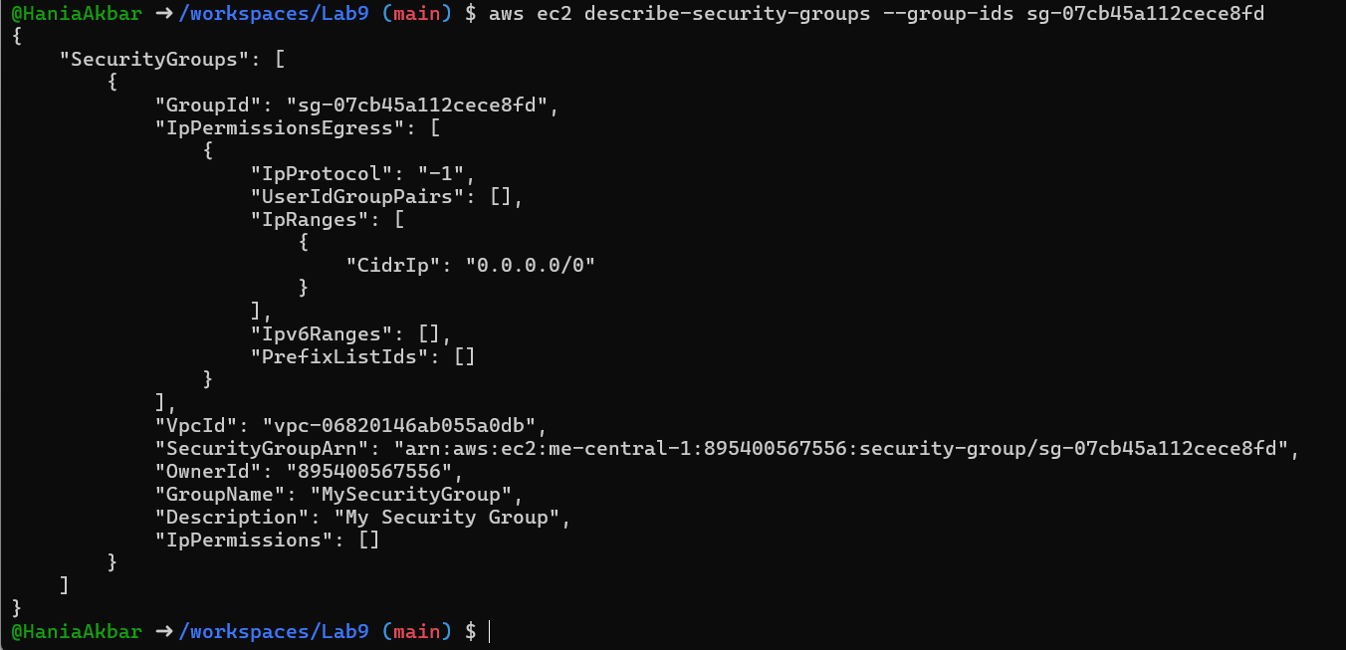
Get your Codespace public IP (from inside the Codespace):

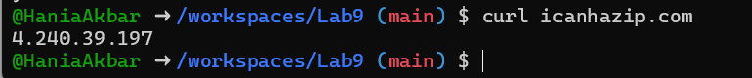

Authorize SSH inbound on port 22 from your Codespace IP:
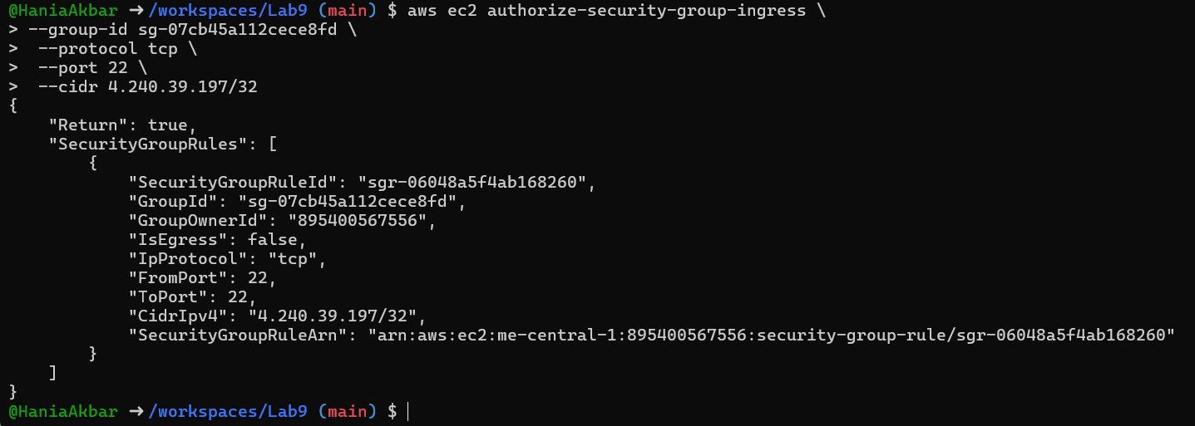
Verify ingress rule appears:


Add an HTTP rule (port 80) using ip-permissions JSON:

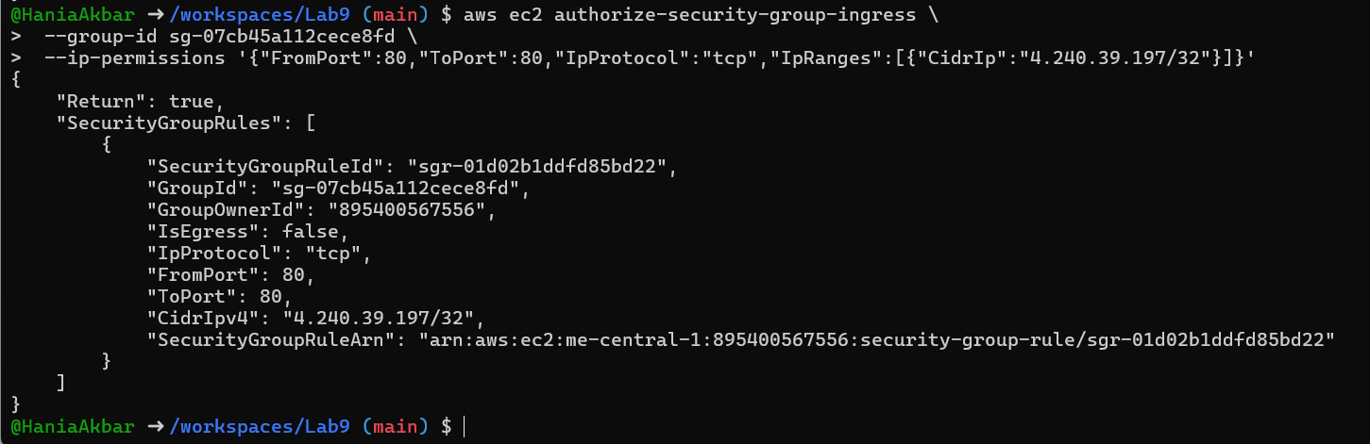

Verify both ingress rules are present:
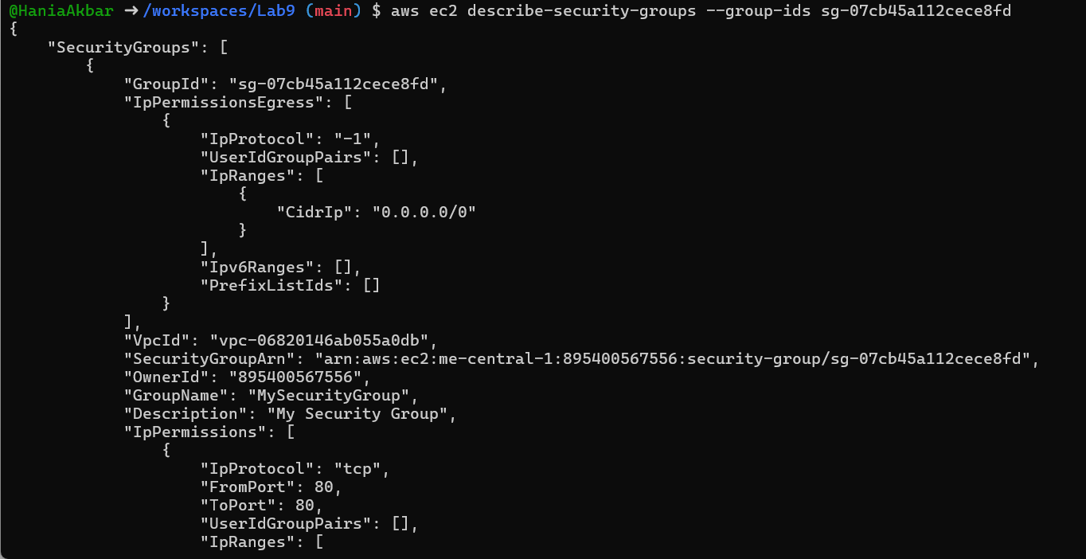

Task 4 — Create a key pair, describe key pairs, and launch EC2 instance
Goal: Create an ED25519 key pair, view it, and launch an EC2 instance using the key pair and the security group created earlier.
Steps:
- Create the key pair and save the PEM file into the Codespace workspace:

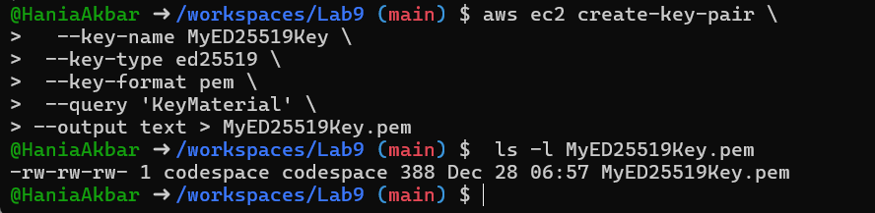

View created key pairs:
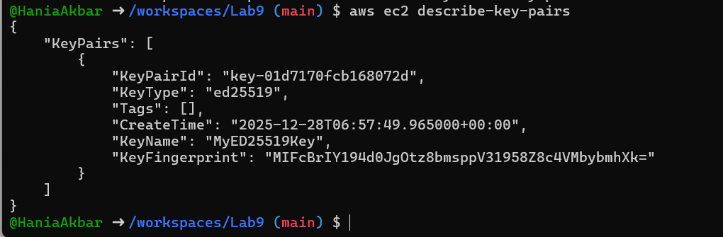
Launch an EC2 instance (example values — replace IDs with ones from your account/region):
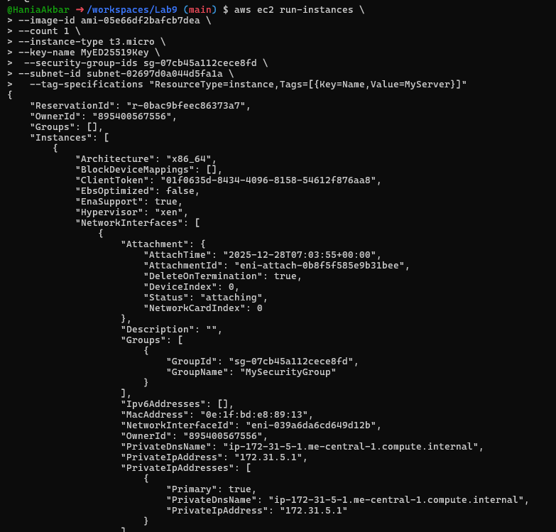
Get the public IP address of your instance:
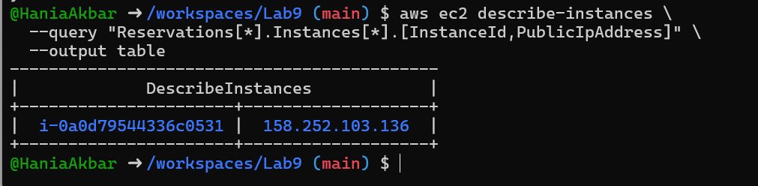

Attempt SSH into the instance from the Codespace or from a machine whose IP is allowed in the security group:
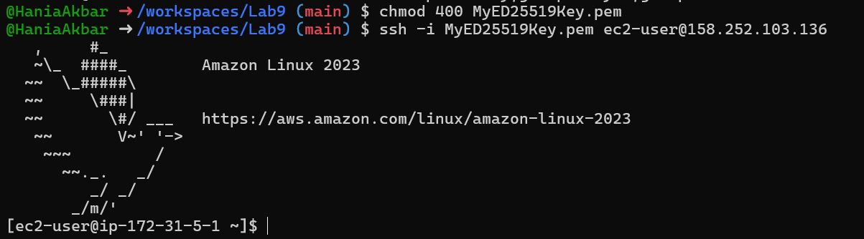

Stop, start and (optionally) terminate the instance:
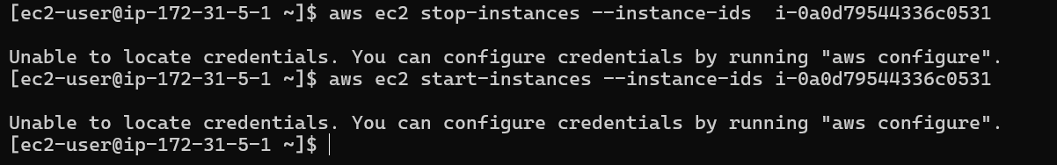

Task 5 — Understand AWS describe-* commands
Goal: Use describe commands to list and inspect AWS resources.
Run and understand these commands (run each, then capture screenshot immediately after):

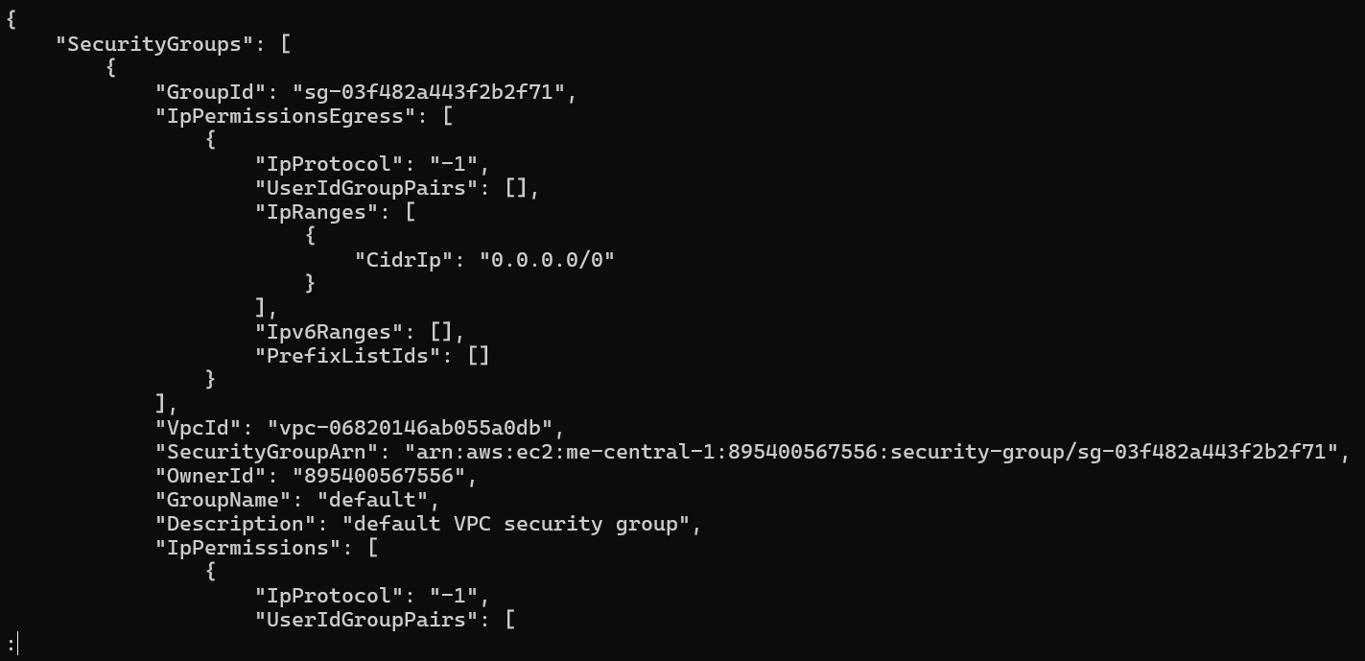

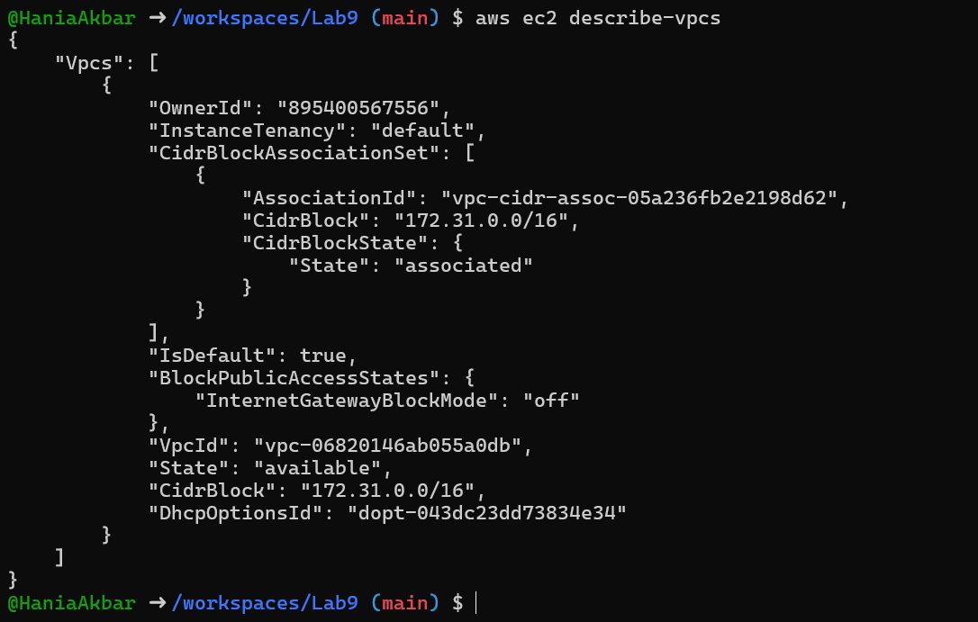

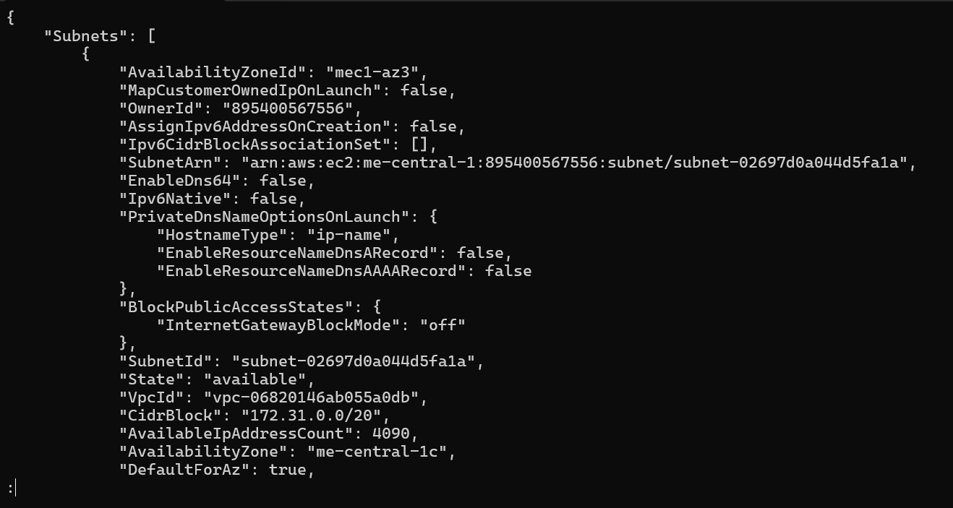

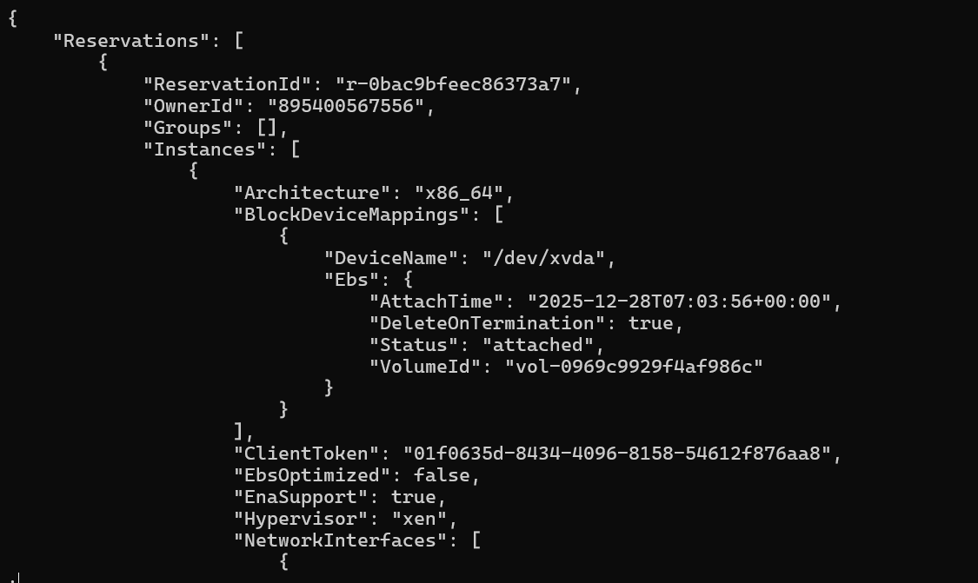

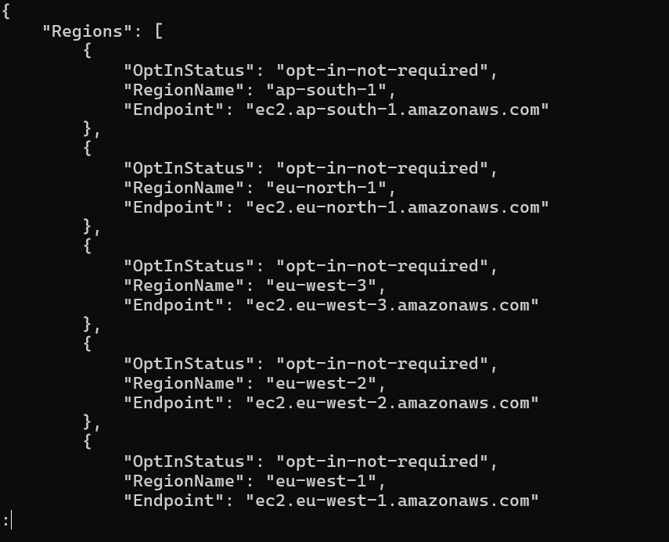

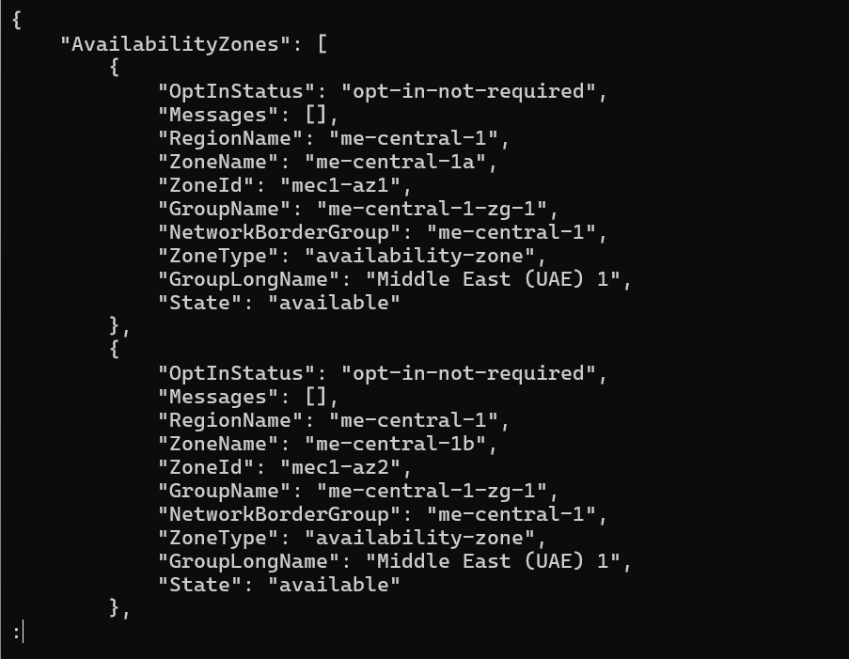

Task 6 — IAM: create group, user, attach policies, create console login & keys
Goal: Practice managing IAM via CLI: create group and user, attach policies, add user to group, create login profile, attach/detach change-password policy, create access keys, and test access via environment variables.
Commands and immediate screenshot request after each step:
- Create group:

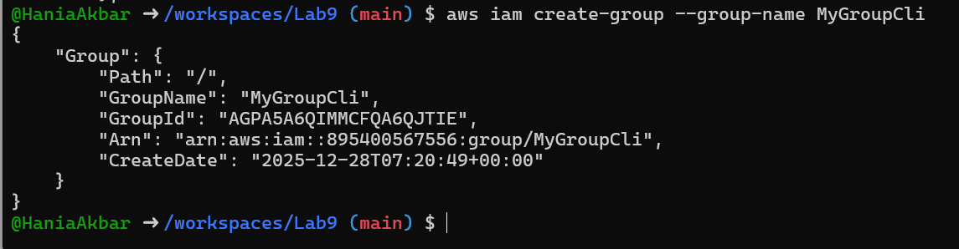

Get group details:
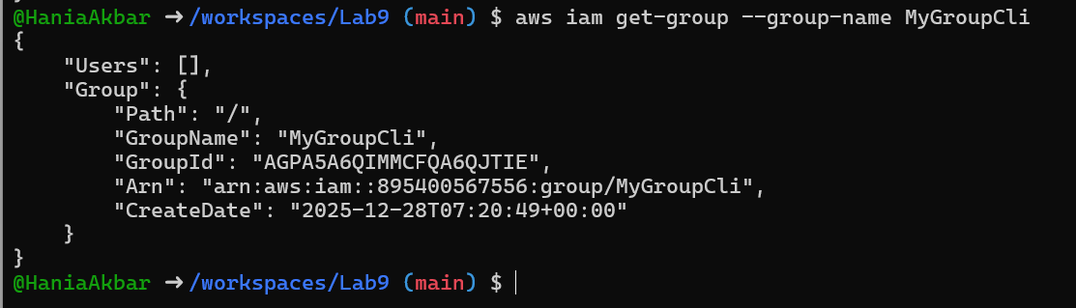

Create user:
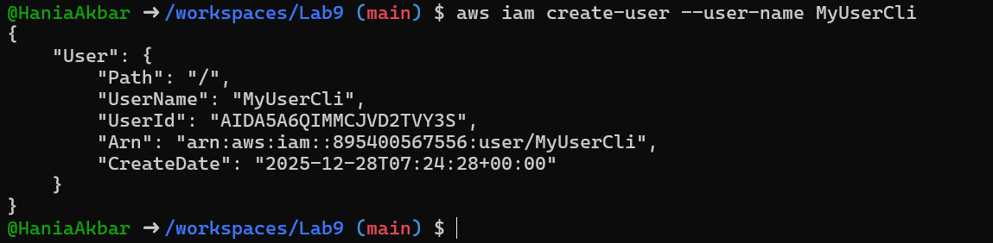
Get user details:
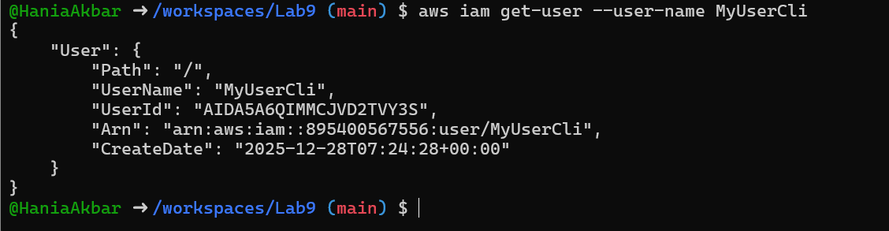

Add user to group:
See group again:
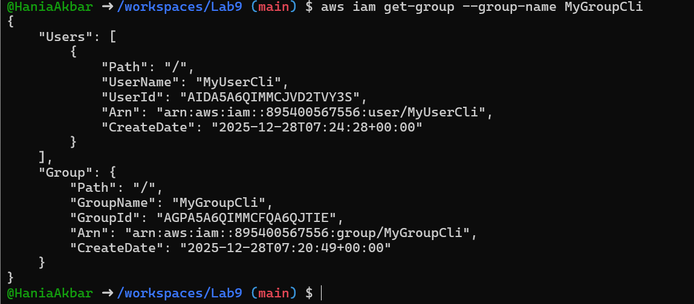
List policies that mention EC2:
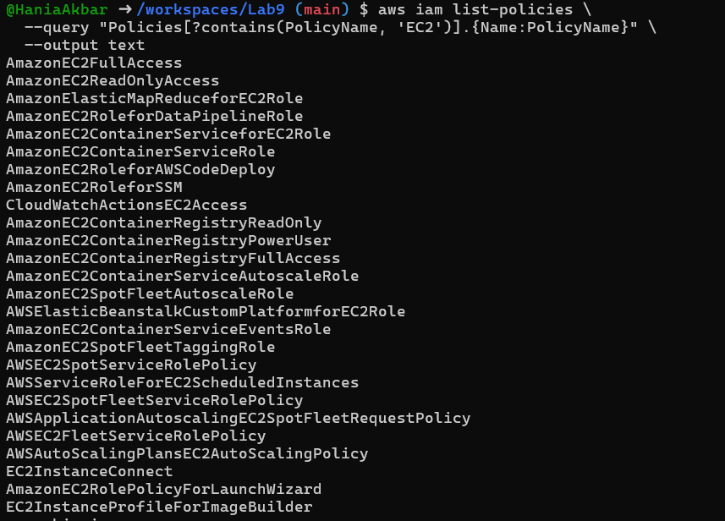
Get ARN for AmazonEC2FullAccess (example query):
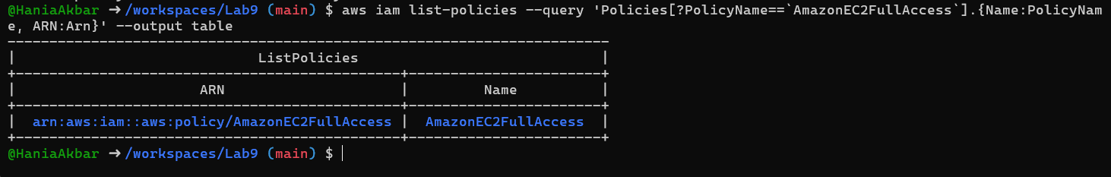
Attach policy to group (use the ARN you retrieved):
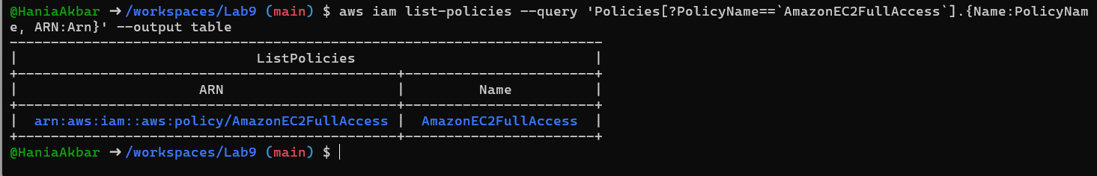
List attached policies for the group:
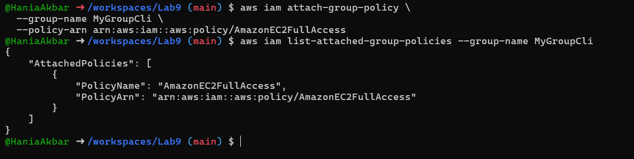
Create a console login profile for the user:
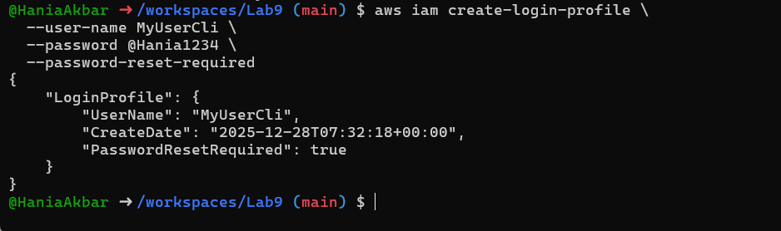

Create access keys for the user (save AccessKeyId and SecretAccessKey securely):
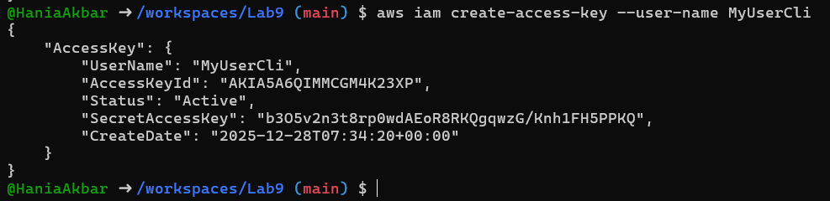
List access keys:
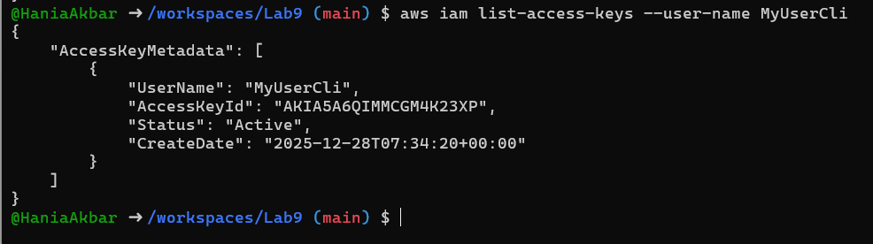
Use environment variables to authenticate as that user in the Codespace:

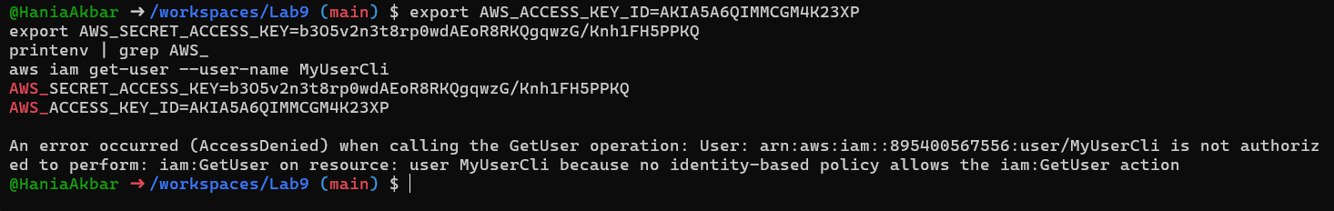

Task 7 — Filters: query with filters to find instances and their attributes
Goal: Use filters and queries to list specific instances and attributes.
Examples (run each and take a screenshot immediately after):

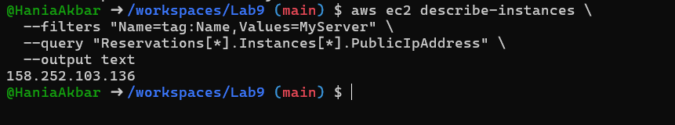

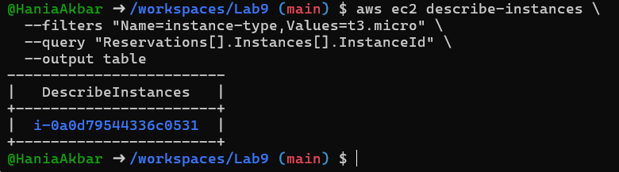

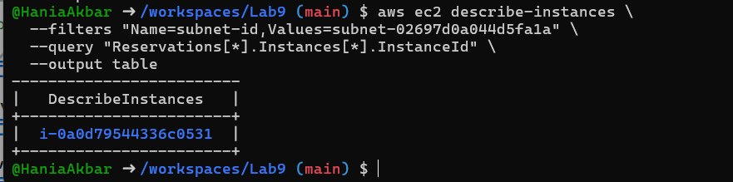

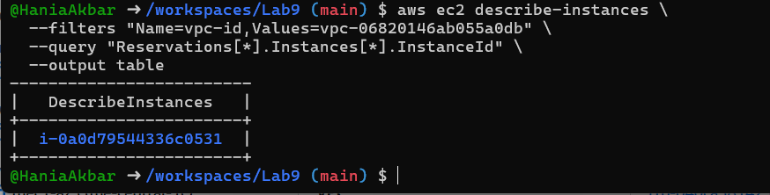

Task 8 — Use --query to format outputs for reporting
Goal: Extract useful fields in table format for reporting.
Examples (run each and take a screenshot immediately after):
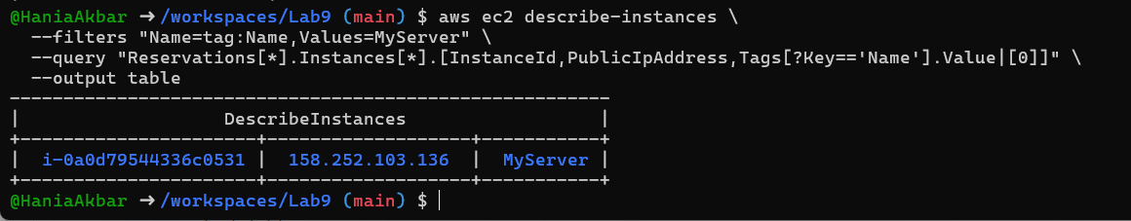

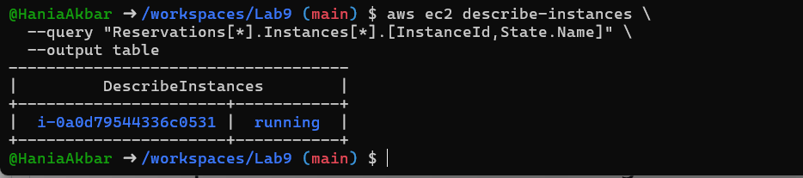
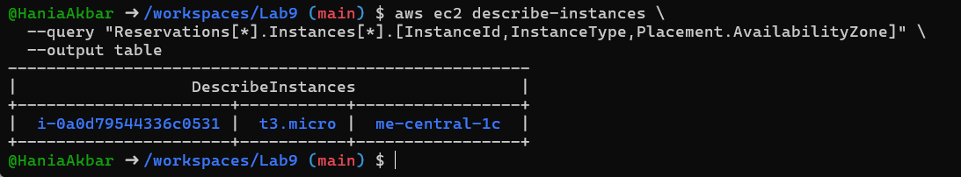

Cleanup — Remove resources to avoid charges
After verification, terminate and delete everything you created in AWS. Capture screenshots for each step.
Cleanup steps and required screenshots (take each screenshot immediately after running the command):
- Terminate instances:

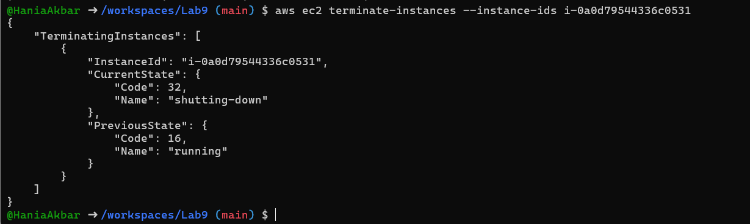
Delete security group and key pair:

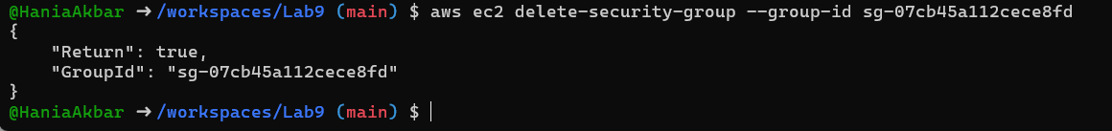
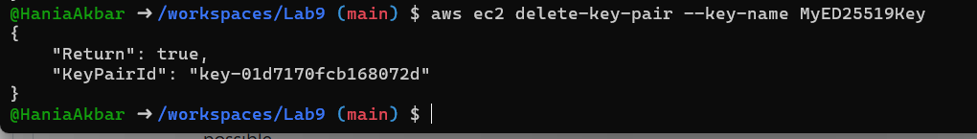
Remove IAM users, access keys, groups:
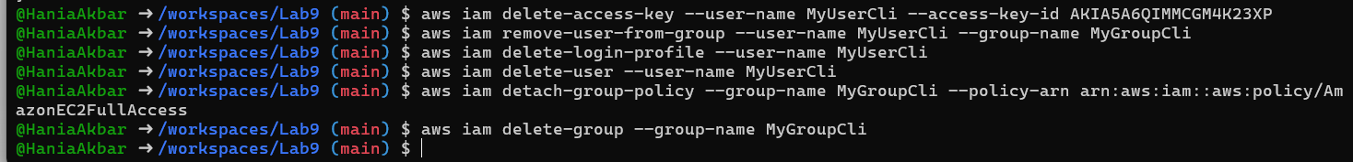

Final verification (billing/resource groups):
